

**Instructor: Sir Faizan**

**Lab Automation**

**MUHAMMAD JIHAD EJAZ– student1364078**

**MUHAMMAD USAMA RIAZ– student1365919**

**SYED ZAFAR HUSSAIN SHAH– student1365598**

# Acknowledgment

I, and behalf of my team who developed the design of the webpage, we would like to show gratitude to each other for helping to complete the project. The chemistry between my group members was significant and hence improved our workforce.

At the end, a very special thanks to our instructor Sir Faizan, who thought us in a productive way and provided us with all facility required.

# Abstract

While developing the project, we learned about the modern websites available to us from professionals.

Our website is developed under the light of the importance of sports and its positive impact on human life. We tried our best to include the factors of sports and to provide valid points to our visitors.

We thoroughly researched thru different platforms.

Contents

Acknowledgment 2

Abstract 3

Problem Statement 5

Solution 5

Features 5

Screenshots 5

Home Page 5

New Arrival 6

Entity relationship Diagram 7

Duration 8

# Problem Statement

According to recent study, most of the people in Pakistan have higher consumer index on food items. They merely spend on fashion footwear. However our website has link with sports, so this threat has drastically reduced our sales.

# Solution

We made some statements to overcome the threat,

* Suitable marketing thru segmentation
* Unique selling point of product

## Features

* User can find sports on the home page
* User can see all the details regarding sports
* User can give a feedback

# Screenshots

## Home Page

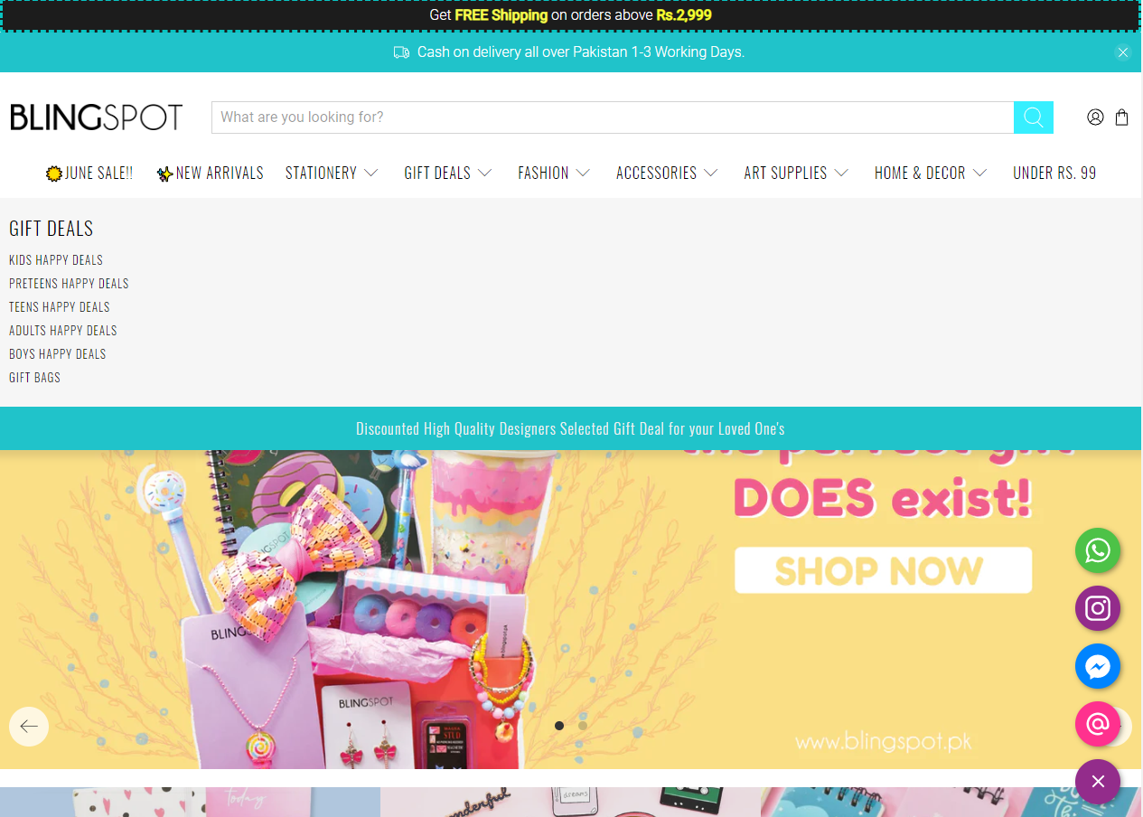

Figure Home Page

This is the home page of our website which shows the information about different products with slider and proper navigation

## New Arrival

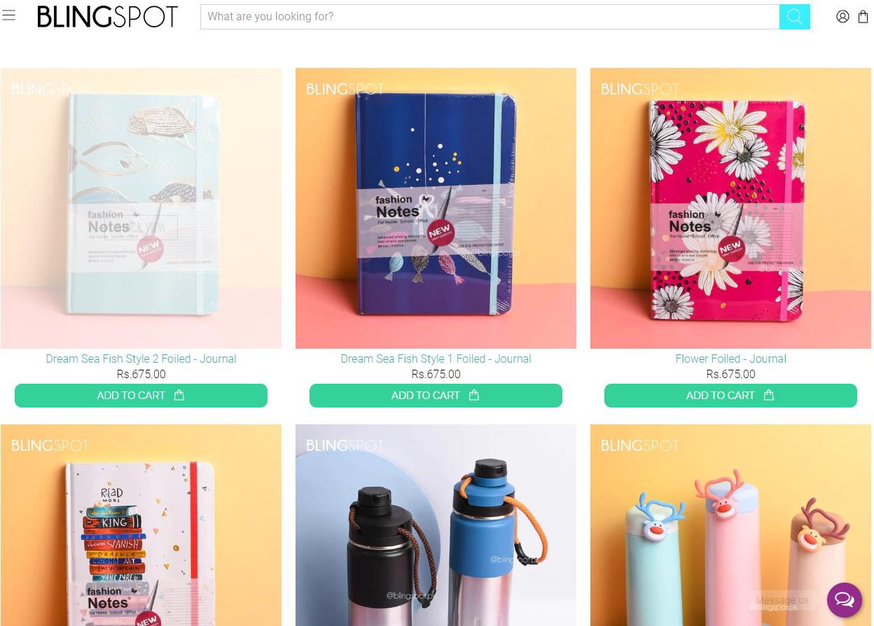

New Arrival

From this section, you can access all the new arrived products on our website.

# Entity relationship Diagram

ERD 1

# Duration

|  |  |  |
| --- | --- | --- |
| Phase | Duration | Member |
| Analyzing | 5 Days | Omaima |
| Designing | 10 Days | Bilal, Hasnain |
| Coding | 10 Days | Omaima, Ahsan |
| Testing | 05 Days | Maleeka |